**Sprint 5 Stories**

1. **Group roles**
   1. Make sure the following roles are existing
      * x_419821_hr.hr_admin
      * x_419821_hr.hr_task_user
      * x_419821_hr.hr_confidential
   2. Add roles to Groups
      * Benefits
        + x_419821_hr.hr_admin
        + x_419821_hr.hr_task_user
      * Confidential
        + x_419821_hr.hr_admin
        + x_419821_hr.hr_task_user
        + x_419821_hr.hr_confidential
      * General HR
        + x_419821_hr.hr_admin
        + x_419821_hr.hr_task_user
      * Payroll
        + x_419821_hr.hr_admin
        + x_419821_hr.hr_task_user
      * Training
        + x_419821_hr.hr_admin
        + x_419821_hr.hr_task_user
2. **Access Control Lists**

Details: We would like to add permissions to both the HR Tickets and HR Tasks. No one outside the HR team are supposed to be able to access HR tickets and tasks except for users with the admin role.

* 1. All users with or without HR roles can Create **HR TICKETS**.
  2. Users without HR roles should be able to see and modify the tickets they opened or are set as the Requested for.
  3. Only users with the OOB admin role can Delete **HR TICKETS** and **HR TASKS**.
  4. Users with the x_419821_hr.hr_confidential role has the following access on **HR TICKETS**.
     + Create
     + Read
     + Write
  5. Users with the x_419821_hr.hr_task_user role has the following access on **HR TICKETS** only if the Type is **NOT CONFIDENTIAL**.
     + Create
     + Read
     + Write
  6. Users with the x_419821_hr.hr_task_user role has the following access on **HR TASKS**.
     + Create
     + Read
     + Write

**Note** before you Test, do the following so that you can easily test the ACLs for users that are not in HR.

Navigate to Service Catalog > My Request Filter and Create a new Record.

Configure the form with the data below and save.

Make sure you can see tickets you submitted from the portal.

1. Navigate to the Service Portal.
2. Click the Request Menu at the top right corner of the portal.
3. You should see a list of Tickets. Make sure You are able to see HR Tickets that you created in the past.
4. HR Notifications.
   1. HR Ticket Created
      * Send only when an HR Ticket is created.
      * Send to Requested for and Opened by.
      * Subject - <The HR Ticket Number> has been opened on your behalf
      * Email body

Hi <Requested for>,

Ticket **<Ticket Number>** has been opened on your behalf.

**Ticket Details:**

**Opened by:**<Opened by>

**Requested for: <Requested for>**

**Short Description: <Short Description>**

**Description: <Description>**

See sample output below.

* 1. HR Ticket Commented
     + Send if the ticket comment changes.
     + Send to Requested for, Opened by and Assigned to.
     + Please see subject and body of email below

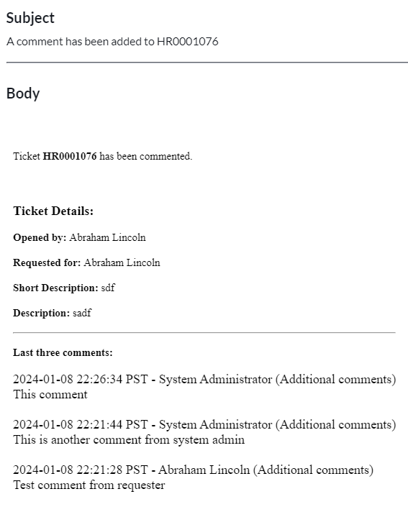

* 1. HR Ticket Resolved
     + Send if ticket changes to Resolved.
     + Send to Requested for and Opened by.
     + Please see subject and body below

* 1. HR Ticket Closed
     + Send if ticket changes to Closed.
     + Send to Requested for and Opened by.
     + Please see subject and body below

* 1. HR Ticket Canceled
     + Send if ticket changes to Canceled.
     + Send to Requested for and Opened by.
     + Please see subject and body below

* 1. HR Assigned to your Group
     + Send if ticket Assignment Group changes and Assigned to is empty.
     + Send to Assignment Group.
     + Please see subject and body below

Note that the link needs to redirect you to the ticket.

* 1. HR Ticket Assigned to You
     + Send if ticket Assigned to changes and is not empty.
     + Send to Assigned to.
     + Please see subject and body below

1. HR TASK Notifications
   1. Create 2 notifications on the HR Task table that mimic the **HR Ticket Assigned to you** and **HR Assigned to your Group** notifications.
      * Show the HR Task Ticket instead of the HR Ticket.
      * Make sure that opened by reflects the Opened by on the HR Ticket.
      * Make sure that requested for reflects the Requested for on the HR Ticket.